OSTIn project: Developing the framework
Mahmud Muhammad, Susanna Jenkins
December 31st, 2024

Introduction
The objective of this part of the project is to develop a suite of probability density functions that describe the inputs required by the NAME model at three timesteps:
- First VONA: Only location and time are known.
- Infrasound data: Plume height range and duration are also known.
- Satellite data
This report focuses on the deliverables for timestep 1. We have developed several Python scripts to stochastically sample the key input parameters: mass eruption rate, duration, and plume height and grain size distribution. These parameters are weighted by the probability of different eruption sizes (VEI), based on data from Whelley et al., (2015).
Since some parameters are interdependent, we sample one based on another, following the workflow outlined below:

Table 1. Volcanic Eruption Analysis Workflow
Step No. | Action | Output
1 | Parse location and volcano name from Volcanic Ash Advisory Center (VAAC) in real-time. | Volcano name and location
2 | Use Whelley et al. 2015 paper to calculate the weighted VEI for the volcano. | Weighted VEI
3 | Estimate total volume using VEI and empirical relationships. | Total Volume (km³ or m³)
4 | Calculate Total Erupted Mass (TEM) using the volume and density estimates. | TEM (kg)
5 | Determine Mass Eruption Rate (MER) using TEM and eruption duration. | MER (kg/s)
6 | Derive eruption duration from TEM and MER. | Duration (hours)
7 | Estimate plume height using MER. | Plume Height (km)
7 | Estimating mass fraction rate of fine debris using MER | M₆₃ fine debris

Whelley et al. (2015) provide the range of possible VEI values for the volcano in question. VEI 0 and 1 are excluded, as they represent effusive eruptions that do not produce airborne tephra. For each explosive VEI (VEI ≥ 2) with a non-zero probability of occurrence at the volcano in question, we stochastically sample the following parameters:
- Bulk Volume: Defined by the VEI (Table 2).
- Total Erupted Mass (TEM): Estimated by assuming a bulk density of tephra from the Independent Volcanic Eruption Source Parameter Archive (IVESPA) datasets. Bayesian techniques are applied to combine prior knowledge of density distributions with sampled evidence, resulting in posterior distributions for more accurate probabilistic mass estimates.
- Mass Eruption Rate (MER): Derived using Bayesian statistics and data from IVESPA (Aubry et al., 2021, 2023), and (Mastin et al., 2009b, 2009a)
- Duration: Calculated as a function of TEM divided by MER.
- Plume Height: Estimated from MER using Bayesian statistical models based on empirical relationships between plume height and MER.
- Mass fraction rate of fine debris: Estimated from MER using Bayesian statistical models based on empirical relationships between Mass fraction rate of fine debris and MER.
Additionally, we have developed a scraping tool to download VONA reports from the Tokyo VAAC website, given the name of the volcano and the timeframe under consideration.

All code is available with readmes on Github: xxxurlxxx

Step 1: Parse location and volcano name
A Python script has been developed to automate the real-time collection and processing of Volcanic Ash Advisory (VAA) notifications. The script is implemented as a class named VEP_TVAAC_VAAText, specifically designed to scrape and analyze data from the Tokyo Volcanic Ash Advisory Centre (TVAAC).
The primary functionalities of this class include:
- Extracting HTML tables from the advisory webpage.
- Identifying and retrieving relevant notifications.
- Processing the data to derive meaningful insights.
- Saving the results in structured formats such as CSV and raw text files.
These capabilities ensure that users can efficiently access, store, and utilize VAA information for further analysis.
In addition to general data collection, the script offers advanced search capabilities, enabling users to filter and extract specific details from VAA reports. This includes information such as the volcano's name, geographic coordinates, and observed ash cloud height (if provided in the advisories).
The next phase involves using the volcano's name to estimate its most probable Volcanic Explosivity Index (VEI). This will be achieved by leveraging data from Whelley et al. (2015), which provides annual VEI probabilities for over 750 volcanoes in Southeast Asia.

Step 2: Calculate weighted VEI using Whelley et al. 2015
Once the location and name of a volcano are identified, this information will be integrated with the Whelley et al. (2015) database. By matching the volcano names extracted from the Volcanic Ash Advisories (VAAs) with entries in the database, the script will cross-reference the data to determine the most probable VEI for each identified volcano.
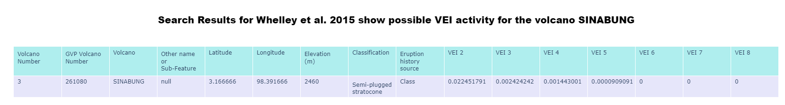
This information is crucial for assessing potential eruption scenarios, as the VEI is a key indicator of an eruption's magnitude, encompassing parameters such as the volume of erupted material.
Figure 1. Show customized information retrieved from VAA report and weighting VEI based on Whelley et al., 2015 database of volcanoes for Southeast Asia region. More detailed output can be found on the GitHub page inside folder named VAA_texts.
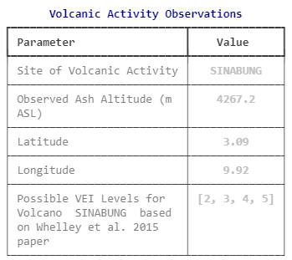

Steps 3 and 4: Estimate Total Volume and Total Erupted Mass (TEM)
Once the potential Volcanic Explosivity Index (VEI) for the target volcano is identified, the assessment is based on well-documented historical volcanoes with known VEI levels and accurately reported total erupted volumes. This approach utilizes historical eruption data to establish a robust foundation for estimating volcanic outputs.
Using this information, we calculated erupted volumes to produce both empirical and probabilistic estimates. Empirical volumes are directly derived from historical data of similar volcanoes, providing a clear baseline for comparison. Probabilistic volumes, on the other hand, are generated using advanced statistical methods that account for uncertainties and natural variability in eruption volumes.

Table 2. VEI Eruption Volumes with References
VEI | Best Estimate Volume (km³) | Example Eruption | Reference
0 | 0.0005 | Kīlauea, Hawai'i (typical lava flows). | U.S. Geological Survey (USGS). (2023). Kīlauea Volcano Activity. [USGS](https://www.usgs.gov/volcanoes/kilauea).
1 | 0.005 | Stromboli, Italy (frequent strombolian activity). | Rosi, M., et al. (2013). Volcanism of the Aeolian Islands. Geological Society, London, Memoirs, 37, 157–211.
2 | 0.1 | Parícutin, Mexico (1943–1952 cone formation). | Luhr, J. F., & Simkin, T. (1993). Parícutin: The Volcano Born in a Mexican Cornfield. Geoscience Press.
3 | 3 | Mount St. Helens, USA (1980 eruption). | Lipman, P. W., & Mullineaux, D. R. (Eds.). (1981). The 1980 Eruptions of Mount St. Helens, Washington. USGS Professional Paper 1250.
4 | 30 | Eyjafjallajökull, Iceland (2010 eruption). | Gudmundsson, M. T., et al. (2010). Eruption of Eyjafjallajökull Volcano, Iceland. EOS Transactions, AGU, 91(21), 190–191.
5 | 100 | Mount Pinatubo, Philippines (1991 eruption). | Newhall, C. G., & Punongbayan, R. S. (1996). Fire and Mud: Eruptions and Lahars of Mount Pinatubo, Philippines. University of Washington Press.
6 | 500 | Krakatoa, Indonesia (1883 eruption). | Simkin, T., & Fiske, R. S. (1983). Krakatau 1883: The Volcanic Eruption and Its Effects. Smithsonian Institution Press.
7 | 1,000 | Mount Tambora, Indonesia (1815 eruption). | Stothers, R. B. (1984). The Great Tambora Eruption in 1815 and Its Aftermath. Science, 224(4654), 1191–1198.
8 | 2,500 | Yellowstone Caldera, USA (Lava Creek eruption ~640,000 years ago). | Smith, R. B., & Siegel, L. J. (2000). Windows into the Earth: The Geologic Story of Yellowstone and Grand Teton. Oxford University Press.
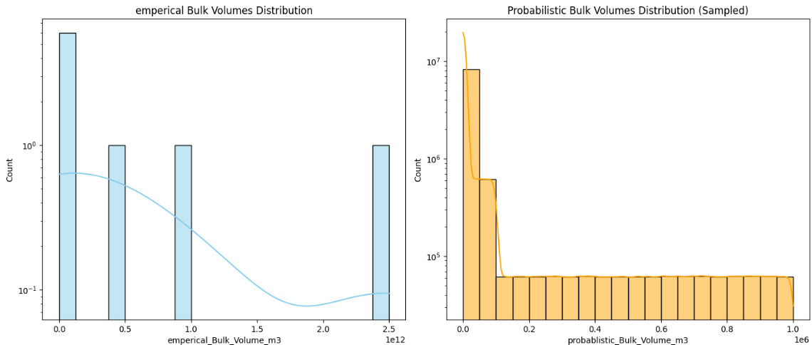
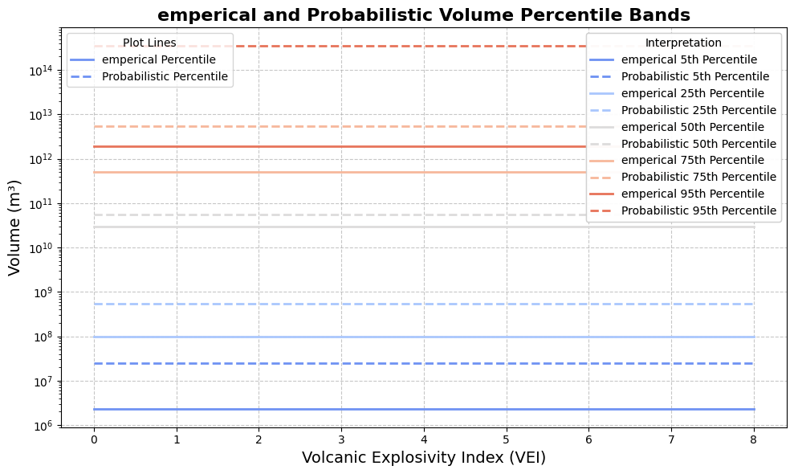
Figure 2. Empirical (observed) and probabilistic volumes for different VEI

The conversion of volume to mass is based on the material's density, which represents the mass per unit volume. The relationship is mathematically expressed as:
Mass = Volume × Density
Parameters:
- Mass: Measured in kilograms (kg).
- Volume: Measured in cubic meters (m³).
- Density: Measured in kilograms per cubic meter (kg/m³).
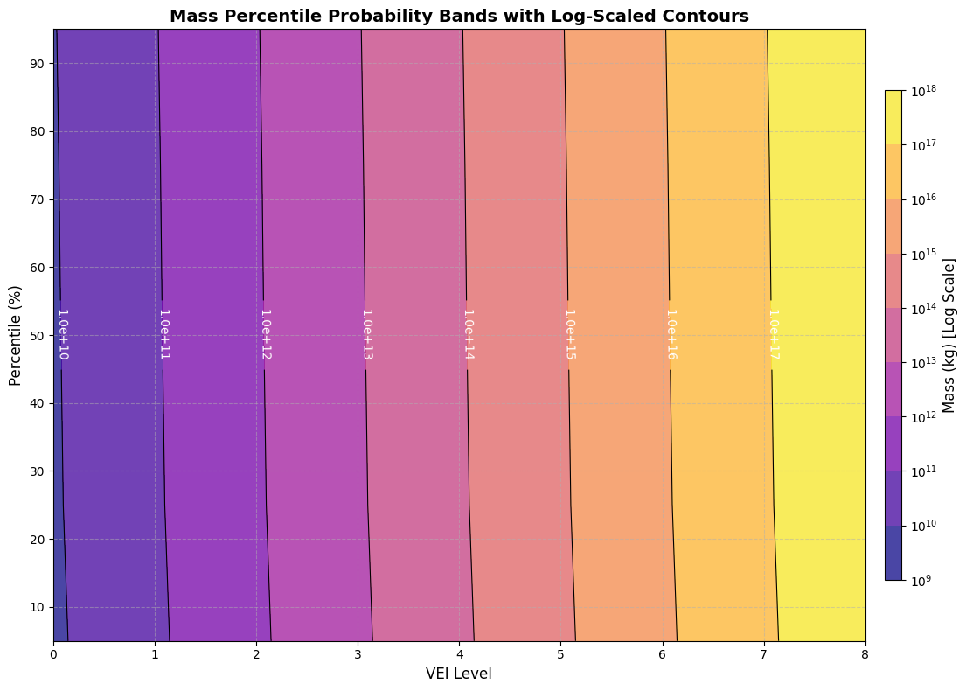
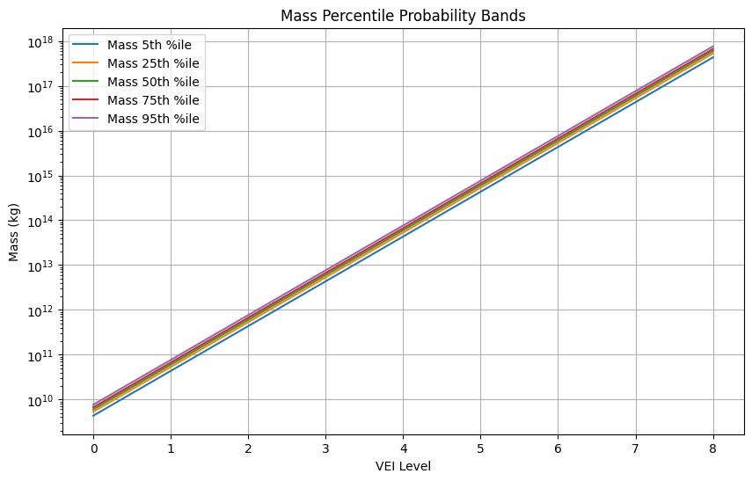
For volcanic materials, such as tephra, typical densities range from 800 to 1200 kg/m³ (Hincks et al., 2018). To enhance the accuracy and robustness of these calculations, the code incorporates observed tephra density values from more than 130 volcanoes recorded in the Independent Volcanic Eruption Source Parameter Archive (IVESPA) database.
Figure 3. Probabilistic Total Eruption Mass (TEM) percentiles relative for different VEI eruption level. Top: line plot of VEI VS TEM at different percentiles. Bottom: Contour plot of VEI VS Percentiles show distribution of TEM.
Steps 5 and 6: Mass Eruption Rate (MER) and Duration
The mass eruption rate (MER) is a critical parameter in volcanology, particularly for understanding the dispersal of volcanic ash in the atmosphere. Despite its significance, directly measuring MER is highly challenging due to the dynamic and unpredictable nature of volcanic eruptions.
To overcome this challenge, empirical databases such as IVESPA, Aubrey (2021), and Mastin et al. (2009) have compiled extensive records of eruption source parameters from past volcanic events. These databases include key parameters such as Total Erupted Mass (TEM), Mass Eruption Rate (MER), plume height, and eruption duration. Typically, MER is estimated using TEM and eruption duration or inferred from plume height observations, as the height of the eruption column is closely correlated with MER.
While these methods are effective for research and retrospective analyses, they are less suitable for operational applications in real-time volcanic hazard simulations. This limitation stems from the lack of critical data—such as Total Erupted Mass (TEM), eruption column height, and duration—during the first few hours of an eruption, precisely when timely hazard forecasts are most crucial.
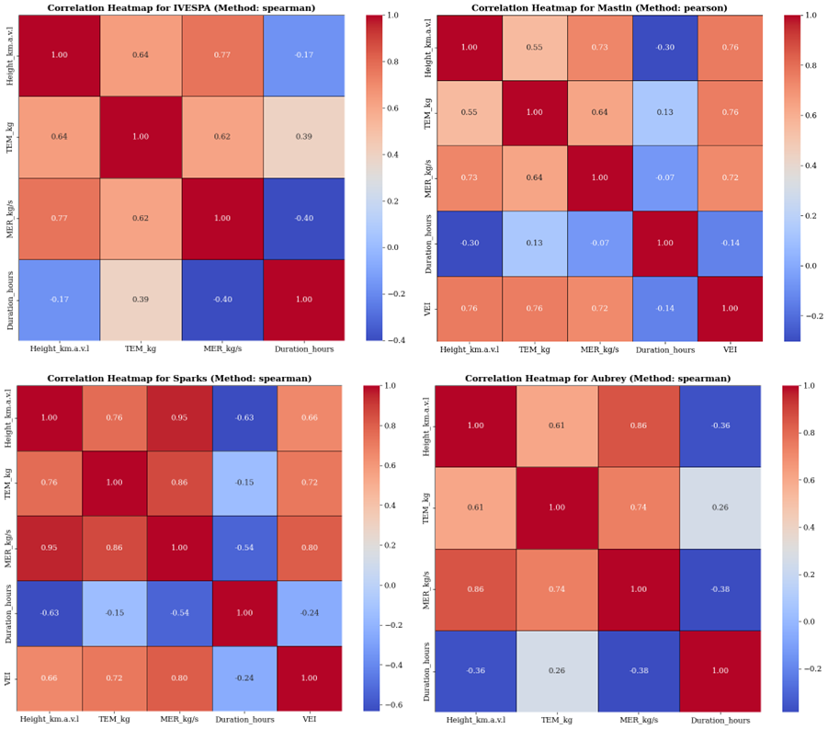
Figure 4 illustrates the correlation coefficients among various eruption source parameters derived from four prominent eruption databases: Mastin, Aubrey, IVESPA, and Sparks.
Figure 4. Correlation coefficients among various eruption source parameters, as derived from four prominent eruption databases: Mastin, Aubrey, IVESPA, and Sparks.
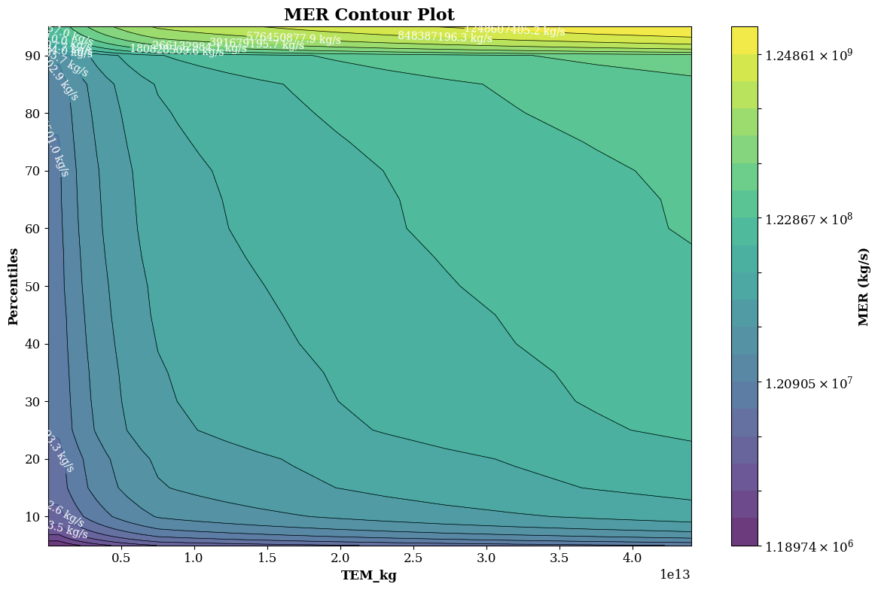
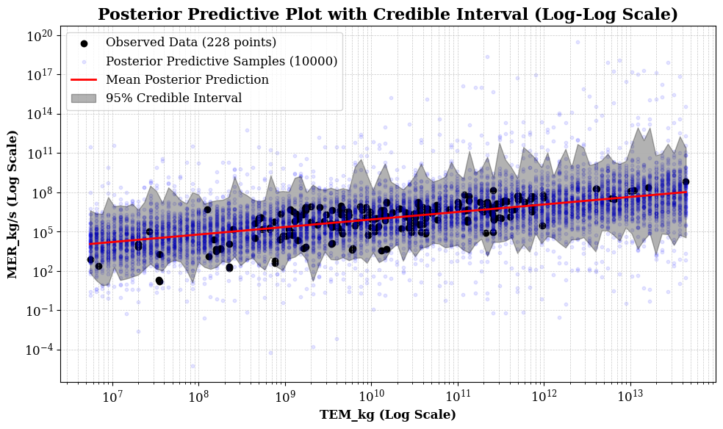
The analysis reveals strong empirical relationships, particularly between TEM and MER, as well as between MER and plume height. These findings highlight the potential of empirical models for estimating MER.
Figure 5. Top panel: Contour plot of MER percentile versus TEM. Bottom Panel: Posterior predictive plot show observed and predicted samples.

Step 7: Estimate plume height
We employ a Bayesian linear regression model to investigate the relationship between volcanic eruption strength, measured as Mass Eruption Rate (MER), and plume height. The model assumes a linear relationship between the logarithms of MER and plume height, a transformation that often simplifies the association and enhances model accuracy.
Parameter estimation is performed using Maximum Likelihood Estimation (MLE), which optimizes the intercept and slope of the regression line by identifying parameters that maximize the likelihood of the observed data, ensuring an optimal fit.
Incorporating Bayesian principles, the model integrates prior assumptions about the MER–plume height relationship. These priors are updated with observed data to produce a posterior distribution, providing a framework that explicitly quantifies uncertainty and enhances interpretability.
To comprehensively assess uncertainty, the model uses techniques to sample from the posterior distributions of key parameters, including the intercept, slope, and variance.
The model is also applied to scenarios with plume height observations, such as those reported in Volcanic Ash Advisory (VAA) notifications. In these cases, it can be used inversely to estimate MER based on observed plume height. By leveraging the established relationship between the logarithms of MER and plume height, the posterior distributions of regression parameters enable probabilistic predictions of MER. This approach is particularly valuable for real-time volcanic monitoring and hazard assessment, providing rapid estimates of eruption strength from plume height measurements.

Mass fraction of fine ash
The grain size of tephra, particularly fine ash, is critical for understanding aviation hazards. Fine ash can travel vast distances, remain suspended in the atmosphere for extended periods, and pose significant risks to aircraft. Volcanic eruptions produce particles ranging in size from several meters to fractions of a micron. Larger particles settle quickly due to their terminal velocity, typically within the first 30 minutes, and deposit near the eruption site. In contrast, the mass fraction of fine ash, a key parameter derived from the total grain size distribution (TGSD), plays a crucial role in hazard assessment.
Accurate TGSD analysis, however, is challenging due to sampling constraints and the dynamic behavior of ash clouds. Immediate sampling, ideally within days of the eruption, is necessary to capture an accurate TGSD, especially in areas where deposits can be accessed over land. Despite its importance, very few studies have successfully conducted such immediate sampling.
In this project, we leverage data from approximately 1,520 Holocene volcanoes cataloged in the Smithsonian Database, which includes information on the mass fraction of fine debris (M63) (Mastin et al., 2009) and mass eruption rates. By analyzing the relationship between mass eruption rate and the mass fraction of fine debris (M63), we produce probabilistic predictions for the mass fraction of fine debris based on given mass eruption rate values.
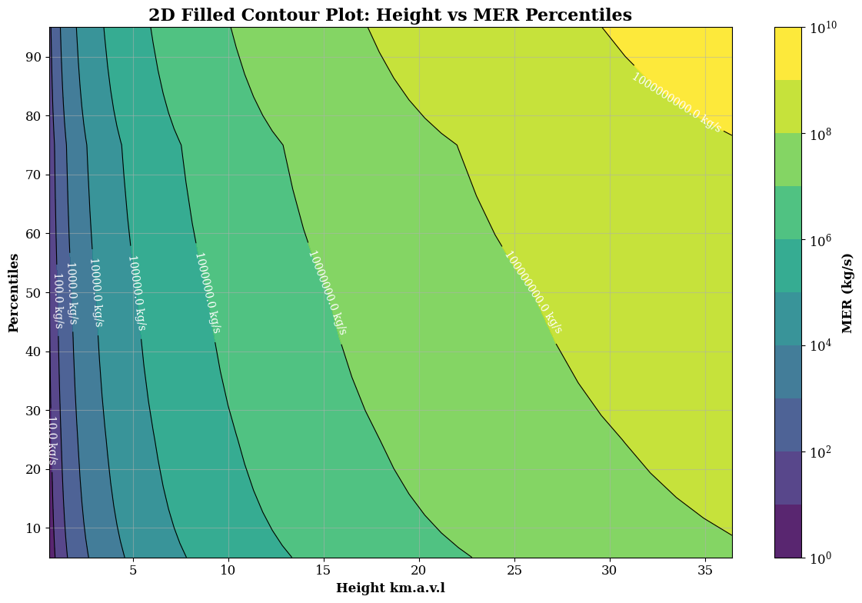
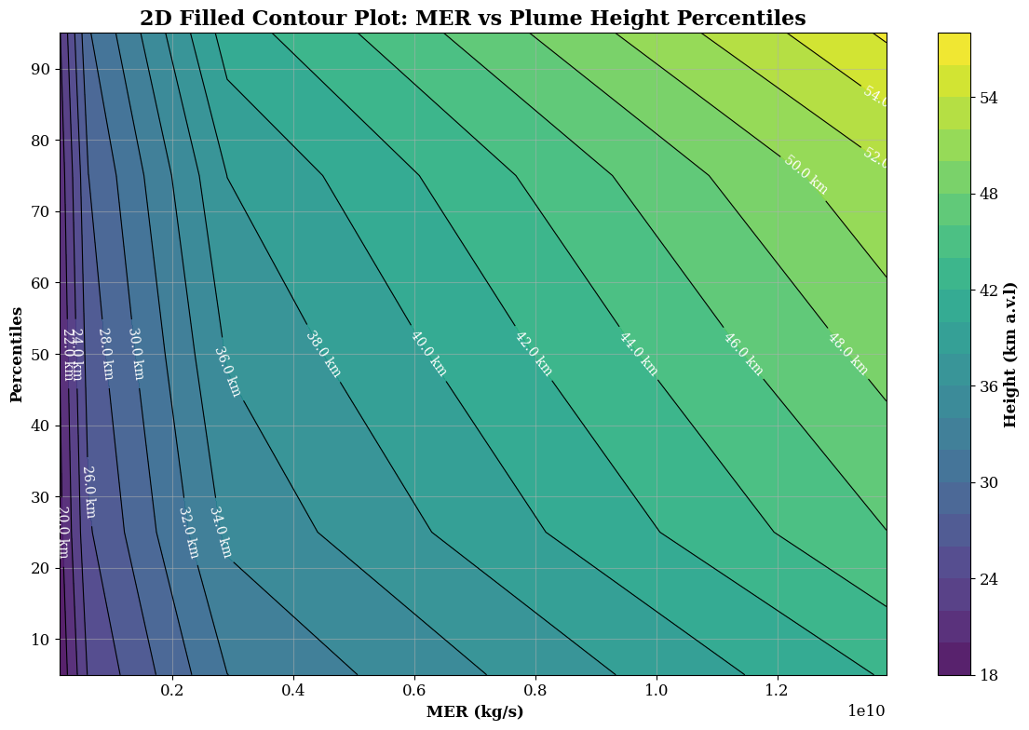
Figure 6. Top panel: Bottom: 2D contour plots of Height percentiles versus MER, aiding in visual interpretation of the model's output. Bottom panel: 2D contour plots of MER percentiles versus plume height, aiding in visual interpretation of the model's output.

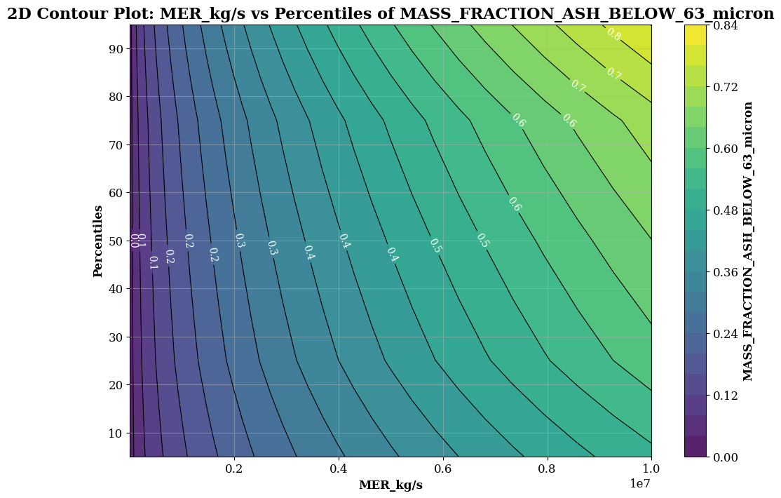
Figure 7. Probabilistic relationship between Mass Eruption Rate (MER) and mass fraction of fine debris.

References
Aubry, T.J. et al., 2023, New Insights Into the Relationship Between Mass Eruption Rate and Volcanic Column Height Based On the IVESPA Data Set: Geophysical Research Letters, v. 50, p. e2022GL102633, doi:10.1029/2022GL102633.
Aubry, T.J. et al., 2021, The Independent Volcanic Eruption Source Parameter Archive (IVESPA, version 1.0): A new observational database to support explosive eruptive column model validation and development: Journal of Volcanology and Geothermal Research, v. 417, p. 107295, doi:10.1016/j.jvolgeores.2021.107295.
Mastin, L.G. et al., 2009a, A multidisciplinary effort to assign realistic source parameters to models of volcanic ash-cloud transport and dispersion during eruptions: Journal of Volcanology and Geothermal Research, v. 186, p. 10–21, doi:10.1016/j.jvolgeores.2009.01.008.
Mastin, L.G., Guffanti, M., Ewert, J.W., and Spiegel, J., 2009b, Preliminary Spreadsheet of Eruption Source Parameters for Volcanoes of the World: U S Geological Survey open-file report Open-File Report 1133, 6 p.
Whelley, P.L., Newhall, C.G., and Bradley, K.E., 2015, The frequency of explosive volcanic eruptions in Southeast Asia: Bulletin of Volcanology, v. 77, p. 1, doi:10.1007/s00445-014-0893-8.

